Case Study Bacchus Winery

Stella Kemp

Dan Zhu

John Smith

Brandon Hasty  
Bellevue University   
Database Development and Use  
Darren Osier  
February 25, 2025

Report One:   
 We created a python script to run a query on the Bacchus database in order to display detailed information on orders made by the company for supplies. Details displayed include delivery_id, supplier_id,, product_id, and quantity ordered. We have tracked the date of expected delivery and the actual date the order arrived. These two values allow the owners of the winery to see if there are any large time gaps or any supplier orders placed that are in transit too long for proper business.   
The list displayed in this query shows that the winery ordered some tubing in February 2025, expecting the deliver_id 1 to to arrive 2-10, but it took an additional three days for the bottle and corks to arrive. All deliveries from suppliers are showing to arrive later than estimated, so this is knowledgeable feedback for the owners.

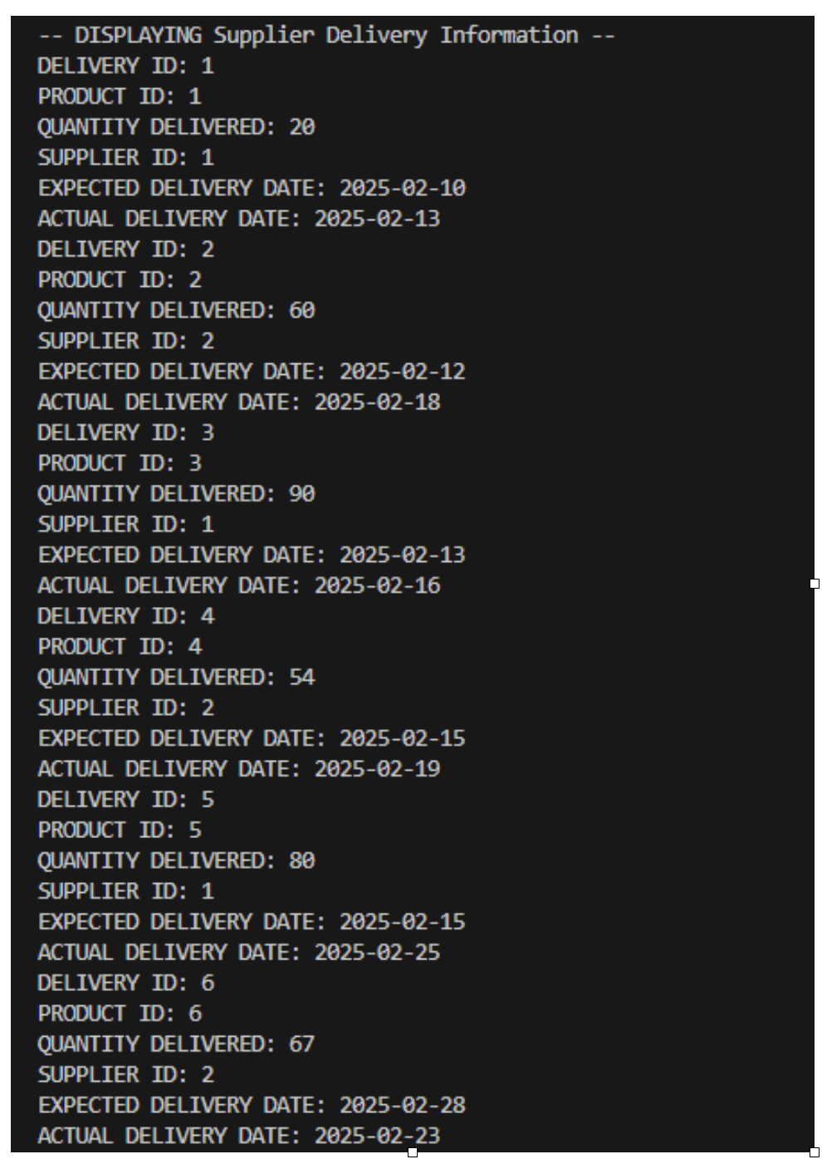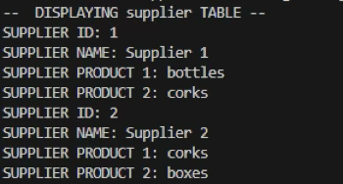

Report Two:   
 For the second report we created a python script to run a query on the Bacchus database for the suppliers and product tables to help automate confirmation of the winery’s annual distribution reports. Stan and Davis want to confirm which distributor supports certain products. We use the product-id and order_id to confirm which wines are being ordered the most. This report will display which wines are being ordered often, or not enough. This report shows that distributor three supports product number four, chardonnay, ordering four cases, while distributor five supports riesling, ordering nine cases!

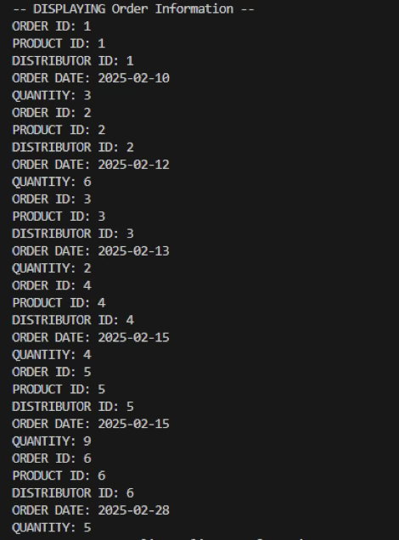 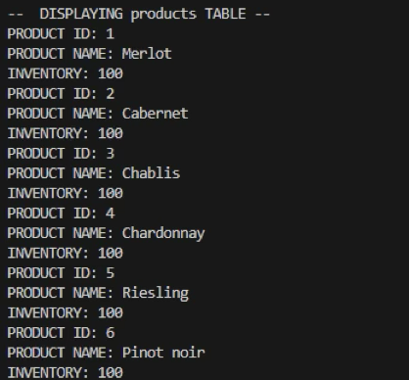

Report Three:

We created a python script to run a query on the Bacchus database for the employees and worked hours tables. The Third Report reviews employee hours for the owners to confirm who is obviously working less hours than their peers, which employees may earn unnecessary overtime hours. Having access to the team's working hours per pay period helps confirm that all employees are working under 45 hours a week, thus giving the presumption that the work balance is so far healthy. The report shows that Henry worked the most hours, and Janet worked the least this last week.

